PRACTICAL 09: Google Form Quiz with Timer

Aim

To create a quiz with automatic grading and time limit.

Objectives
•To automate quiz assessment
•To use time limit add-on

Materials Required
•Google Forms
•Timer add-on

Procedure
1. Create Google Form
Open Google Forms and start a new blank form to set up the structure of your activity.

2. Convert to quiz
Enable “Make this a quiz” in the settings so you can assign points and correct answers.

3. Add 5 MCQs + 1 short answer
Insert five multiple-choice questions and one short-answer question, customizing options and points.

4. Enable 1-response limit
Turn on “Limit to 1 response” so each user can submit the form only once.

5. Shuffle questions –
Activate the shuffle feature to randomize the order of questions for every respondent.

6. Add timer add-on
Install a timer add-on from the Add-ons menu to set and control the quiz duration.

7. Send link
Use the “Send” button to generate and share the form link with participants.

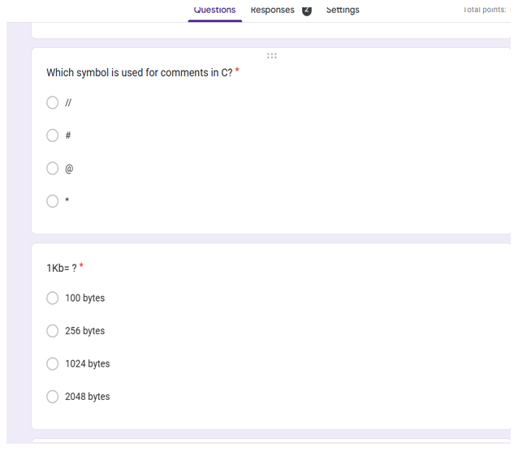
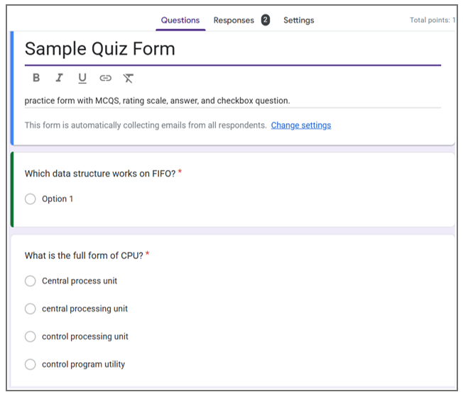
Output:
